TEST **3 PYTHON FUNCTIONS**

**MCQ**

1) b. [(‘a’,1),’(b’,2),(‘c’,3)]

2) d. [1,2,3]

3) c. (4,9,16,25)

4) c. def

5) d. return statement is compulsory in function

6) a. math

7) b.**

8) d. no error

9) c. Both a and b

10) a.12

**Short answer**

**1** define function?

Function is a block of code that perform specific task. It is defined by using keyword “def”.

Syntax:

**def function_name ()**

**2.**  Use of return statement?

The “return” statement in a function is used to specify the value that the function should return when it is called. Once the return statement execute it exit the current function and send value to specified code.

Syntax:

**return** function_name

3.Lambda functions

A lambda function, also known as a lambda expression or anonymous function, is a simple and short function designed to be created inline within code without being assigned a formal name

Syntax:

**lambda** arguments: expression

4.Default arguments:

Default arguments are parameters in a function that have predefined values. When calling the function if a value for a default argument is not provided, the function will use the default value specified in the function definition.

5. Use of filter

The filter() function in Python is used to filter elements from an iterable (e.g., a list, tuple, or string) based on a given function (predicate). It returns an iterator containing the elements for which the function returns **True**.

Syntax

filter(function, iterable)

**Program writing:**

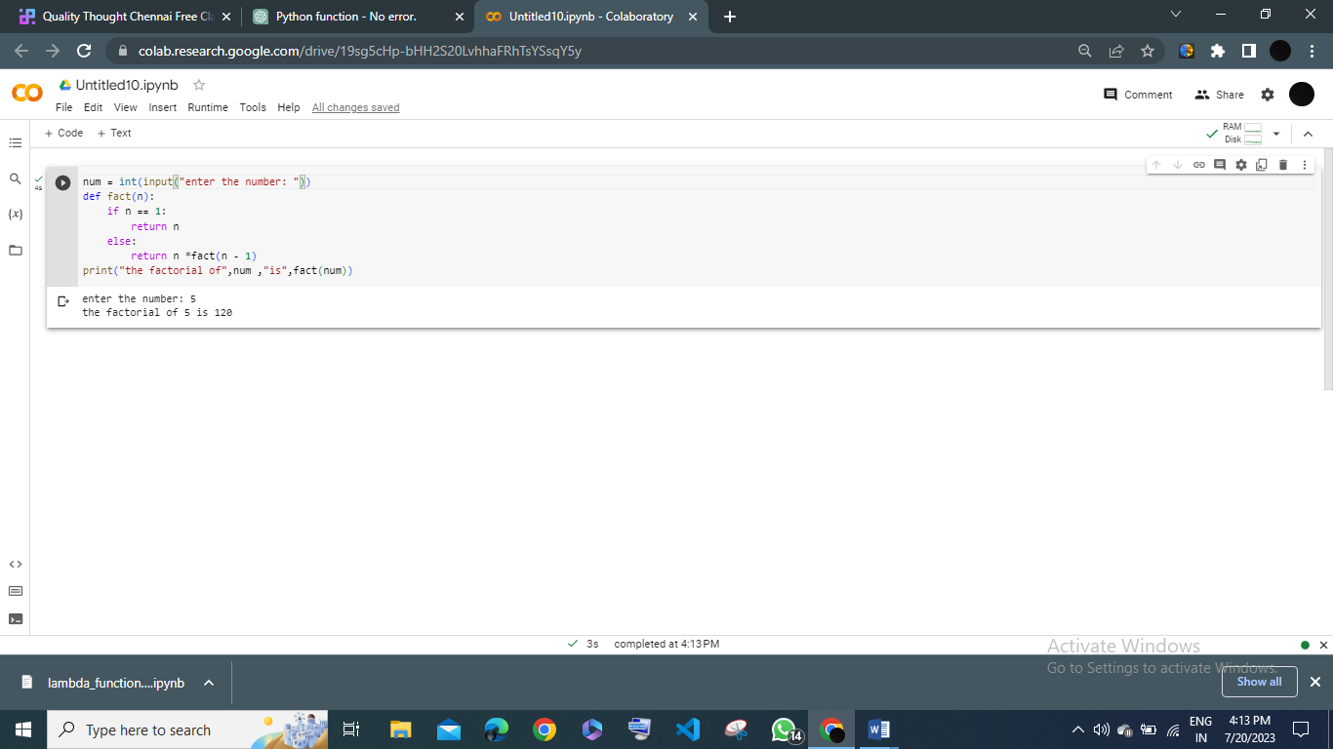 **16.**

17. Built in function

1. print ()

Print function is used to display output in the screen

Ex:

print(“hello quality thought”)

o/p

hello quality thought

2. len()

This function returns the length of a sequence, such as a string, list, tuple, or dictionary.

Ex:

Print(len(Hello))

o/p

5

3.range()

Range function generates a sequence of numbers within a specified range.

Ex:

for i in range(5):

print(i, end=" ")

Output:

0 1 2 3 4

4.**sum()**:

This function calculates the sum of elements in an iterable (list, tuple).

Ex:

numbers = [1, 2, 3, 4, 5]

total = sum(numbers)

print(total)

Output:

15

5.**sorted()**:

This function returns a new sorted list from the elements of an iterable.

Ex:

a = ['b', 'd', 'a', 'c']

sort = sorted(letters)

print(sort)

Output:

['a', 'b', 'c', 'd']

17. L.C.M program

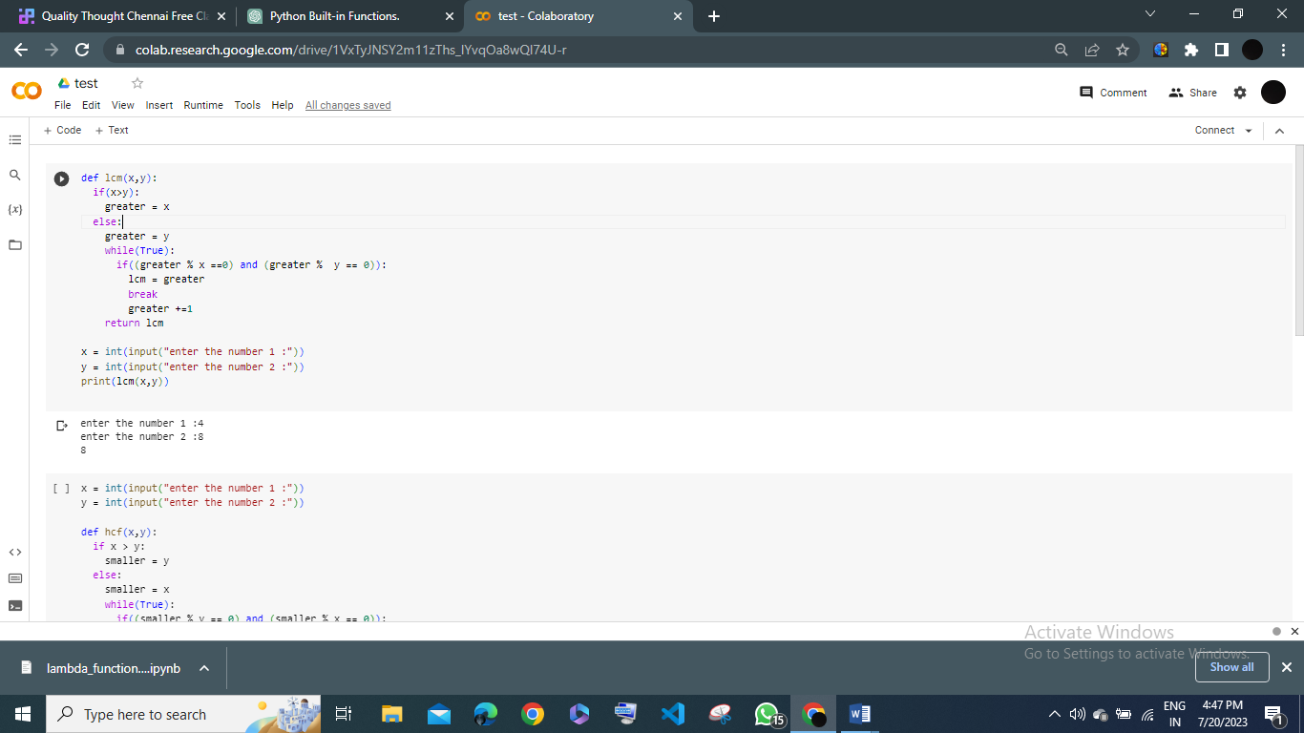

19. Fibonacci series

num = int(input(“enter the number”)

n1,n2 = 0,1

print(n1,n2, end = “ ”)

for i in range(2,num):

n3=n1 + n2

n1 = n2

n2 = n3

print(n3,end = “ “)

OUTPUT

Enter the number 6

0

1

1

2

3

5